LECTURE 7
BLOCKCHAIN APPLICATIONS

1. Blockchain in Healthcare
Blockchain is a technology that can be used in healthcare to securely store, manage, and share medical data between different healthcare organizations.
It helps manage important healthcare information such as:
- Electronic Health Records (EHR)
- Medical supply chains
- Drug tracking
- Clinical trial data
- Health insurance claims
- Patient identity management
Goal of Blockchain in Healthcare
The main goal is to create a healthcare system that is:
- Secure – protects sensitive patient information
- Transparent – records cannot be secretly changed
- Interoperable – different hospitals can easily share data
Using blockchain improves data accuracy, trust, and efficiency in healthcare systems.

2. Why Blockchain is Needed in Healthcare
Traditional healthcare systems face many problems that blockchain can help solve.
1. Fragmented Medical Records
Patient records are stored in separate hospital databases.
Example:
A patient visits Hospital A and later visits Hospital B.
Hospital B cannot easily access the patient’s previous records.
2. Data Security Issues
Healthcare databases are often targets for cyberattacks and data breaches.
Sensitive information like medical history and personal data can be stolen.
3. Lack of Transparency
Medical records or clinical trial data can sometimes be modified or manipulated.
This reduces trust in healthcare data.
4. Slow Data Sharing
Many hospitals still use manual systems or paper documents to share data.
This makes information sharing slow and inefficient.
5. Insurance Fraud and Delays
Health insurance claims involve large amounts of paperwork and manual verification, which can cause:
- Fraud
- Long delays
- Processing errors

3. How Blockchain Solves Healthcare Problems
Blockchain solves these problems using several important features.
1. Decentralization
Data is stored across multiple nodes instead of one central server.
Benefits:
- No single point of failure
- Better system reliability
2. Data Integrity
Blockchain records cannot be changed once they are stored.
This ensures that medical information remains accurate and trustworthy.
3. Cryptographic Security
Patient data is encrypted using cryptography.
Only authorized users with the correct keys can access the information.
4. Transparent Record Sharing
Blockchain allows authorized healthcare providers to access verified patient data.
Every access or transaction is recorded, creating a transparent audit trail.

4. How Blockchain Works in Healthcare
The process of using blockchain in healthcare generally follows these steps:
Step 1: Patient Visits Hospital
A patient goes to a hospital for treatment.
Step 2: Medical Record is Created
Doctors create medical data such as:
- Diagnosis
- Test results
- Prescriptions
- Treatment history
Step 3: Data is Encrypted
The medical data is encrypted to protect patient privacy.
Step 4: Hash Stored on Blockchain
A hash of the medical record is stored on the blockchain.
The actual data may remain in a secure database, while the blockchain stores a verification proof.
Step 5: Access Control Using Smart Contracts
Smart contracts control who can access the medical data.
Example:
- Doctors
- Specialists
- Insurance companies
Step 6: Data Verification
Authorized users can verify the medical record by checking the hash stored on the blockchain.
If the record changes, the hash will also change, making tampering easy to detect.
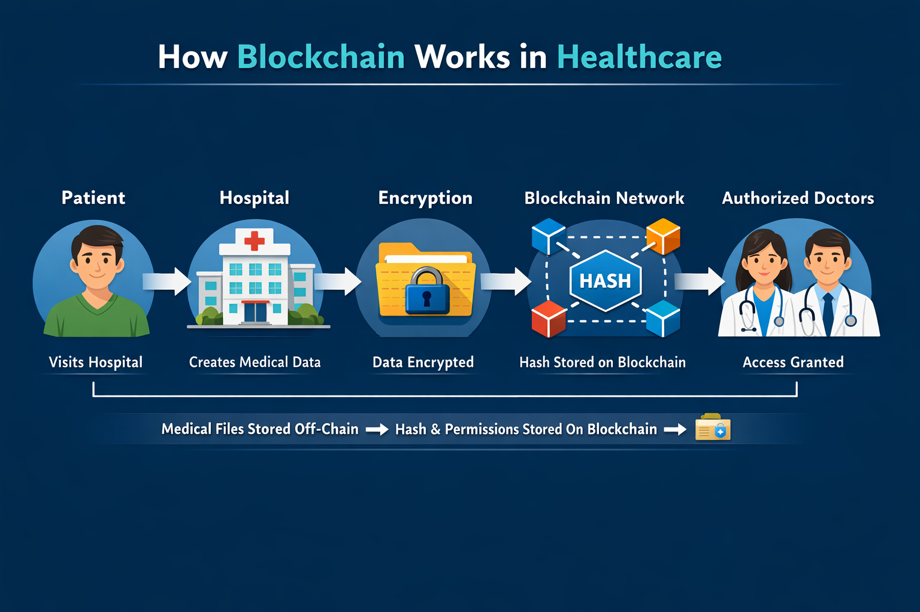

5. Key Applications of Blockchain in Healthcare
Blockchain technology has several important applications in healthcare.
It helps improve security, transparency, and efficiency in different healthcare processes.
5.1 Electronic Health Records (EHR)
Electronic Health Records (EHR) are digital records that store a patient’s medical history, treatments, test results, and prescriptions.
Problem
Patient records are usually stored in separate hospital databases.
Example:
- A patient visits Hospital A and receives treatment.
- Later the patient visits Hospital B.
- Hospital B cannot easily access the patient's previous records.
This leads to:
- Repeated tests
- Delays in treatment
- Incomplete medical history
Blockchain Solution
Blockchain stores indexes or hashes of patient records that can be accessed by authorized hospitals.
Patients can control who can access their medical data.
Benefits
- Easy access to patient history
- Better treatment decisions
- Improved data security
- Reduced duplication of medical tests
5.2 Drug Supply Chain Management
The drug supply chain includes the process of delivering medicines from manufacturers to pharmacies and hospitals.
Problem
Counterfeit (fake) medicines are a serious global problem.
Fake drugs enter the supply chain because:
- Tracking systems are weak
- Supply chain information is not transparent
Blockchain Solution
Each drug package is recorded on the blockchain at every stage of the supply chain.
Stages recorded include:
- Manufacturer
- Distributor
- Wholesaler
- Pharmacy
Benefits
- Track medicine origin
- Detect counterfeit drugs
- Improve transparency in the supply chain
- Ensure drug safety
5.3 Medical Data Sharing
Healthcare organizations often need to share patient data with:
- Specialists
- Laboratories
- Research institutions
Problem
Traditional data sharing methods are:
- Slow
- Insecure
- Difficult to manage
Hospitals often rely on paper reports or manual communication.
Blockchain Solution
Blockchain allows secure sharing of medical data using smart contracts.
Smart contracts control who can access the data and for how long.
Example Process
Hospital uploads encrypted patient data
↓
Smart contract is created
↓
Specialist receives permission to access data
↓
Specialist reads verified medical record
Benefits
- Secure data sharing
- Faster collaboration between doctors
- Better patient care
5.4 Clinical Trials Management
Clinical trials are research studies used to test new medicines or medical treatments.
Problem
Clinical trial data must be accurate and reliable, but problems may occur such as:
- Data manipulation
- Data loss
- Lack of transparency
This can reduce trust in research results.
Blockchain Solution
Clinical trial data can be stored on blockchain, making it permanent and tamper-proof.
Benefits
- Prevents data manipulation
- Ensures research transparency
- Increases trust in clinical trial results
- Provides secure record keeping
5.5 Health Insurance Claims
Health insurance companies pay hospitals for patient treatments through insurance claims.
Problem
The traditional claims process involves:
- Large amounts of paperwork
- Manual verification
- Long processing times
- Risk of fraud
Blockchain Solution
Blockchain uses smart contracts to automate insurance claims.
Example Process
Patient receives treatment
↓
Hospital uploads treatment record
↓
Smart contract verifies insurance policy
↓
Claim is automatically approved
↓
Payment is released
Benefits
- Faster claim processing
- Reduced paperwork
- Lower fraud risk
- Increased transparency

6. Example of Blockchain Healthcare Workflow
This example explains how blockchain is used step-by-step in a healthcare system to manage patient records securely.
Step 1: Patient Visits Hospital
A patient goes to a hospital for consultation or treatment.
Step 2: Doctor Generates Medical Record
The doctor creates a medical record that may include:
- Diagnosis
- Test results
- Prescriptions
- Treatment details
Step 3: Record is Encrypted
The medical record is encrypted to protect patient privacy.
Encryption ensures that only authorized users can read the data.
Step 4: Hash Stored on Blockchain
A hash of the medical record is stored on the blockchain.
- The actual record may remain in a secure database.
- The blockchain stores the hash as proof of authenticity.
If the data is modified, the hash will change, making tampering detectable.
Step 5: Smart Contract Controls Access
A smart contract manages access permissions.
Only authorized users such as:
- Doctors
- Specialists
- Hospitals
- Insurance companies
can access the data when permitted.
Step 6: Authorized Doctors Access Record
Doctors or specialists with permission can verify and access the patient’s medical record.
Benefits of this workflow:
- Secure patient data
- Easy access for authorized healthcare providers
- Protection against data tampering
- Faster information sharing
7. Class Activity
Task
Students are required to find real-world blockchain healthcare projects and explain their architecture.
Objective
The purpose of this activity is to help students:
- Understand how blockchain is used in real healthcare systems
- Study the architecture of blockchain healthcare solutions
- Analyze how blockchain improves security and data sharing
What Students Should Do
- Research real blockchain healthcare projects.
- Study how the system works.
- Identify the main components of the architecture.
Possible components may include:
- Blockchain network
- Smart contracts
- Hospitals or healthcare providers
- Patient data storage
- Access control mechanisms
Expected Outcome
Students should be able to explain how blockchain technology is implemented in healthcare applications.

